PENNSYLVANIA BLUE DOG DEMOCRATS
Jason Altmire, (PA-04)
http://www.altmire.house.gov

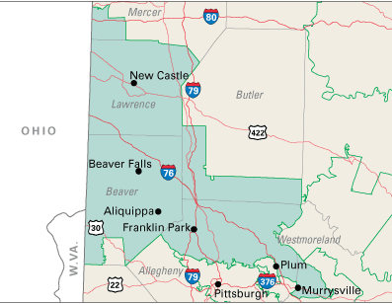

Main Offices
Please direct all written correspondence to the Aliquippa District Office.

Aliquippa Office
2110 McLean Street
Aliquippa, PA 15001
724-378-0928
724-378-6171 (fax)
Natrona Heights Office
2124 Freeport Road
Natrona Heights, PA 15065
724-226-1304
724-226-1308 (fax)
Washington, D.C. Office
332 Cannon House Office Building
Washington, DC 20515
202-225-2565
202-226-2274(fax)

Satellite Offices

Cranberry Township Office
Cranberry Township Municipal Building
2525 Rochester Road
Cranberry Township, PA 16066-6499
1:30 pm to 5:00 pm - First and Third Thursdays of every month
NOTE: This office will be closed on Thursday, July 3.

Ellwood City Office
Ellwood City Municipal Building
Lawrence Avenue
Ellwood City, PA 16117
2:00 pm to 6:00pm - 2nd and 4th Tuesday of every month

Farrell Office
Farrell City Building
500 Roemer Blvd
Farrell, PA 16121
9 am to 1:00 pm - 2nd and 4th Tuesday of every month

Murrysville Office
Murrysville Municipal Building
4100 Sardis Road
Murrysville, PA 15668
2 pm to 4 pm - Second Tuesday of every month
4 pm to 7 pm - Fourth Tuesday of every month

New Castle Office
Lawrence County Government Center
430 Court Street
1st Floor Caucus Room
New Castle, PA 16101
8:00 am to 4:00 pm - Every Wednesday and Friday

Ross Township Office
Ross Township Municipal Building
Recreation Center
1000 Ross Municipal Drive
Pittsburgh,PA 15237
9:00 am to 12:00 pm - First and Third Thursdays of every month
NOTE: This office will be closed on Thursday, July 3.

Please direct all written correspondence to the Aliquippa District Office.
Carney, Christopher (PA-10)
http://carney.house.gov

One of my goals as your Congressman is to have a town hall meeting in each of our 14 counties. I also have three district offices in Clarks Summit, Williamsport, and Shamokin for your convenience. Both my Constituent Services Director and my Regional Director are available for the people of Northeast and Central PA in locations across the district.

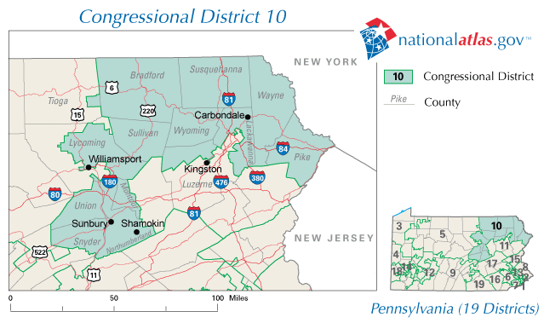

Office Information
Washington D.C. Office  416 Cannon House Office Building  Washington, DC 20515  Phone: (202) 225-3731  Fax: (202) 225 9594  Congress in Session:  Office Hours: Monday - Friday, 9:00 - 6:00  Congress in Recess:  Office Hours: Monday - Friday, 9:00 - 5:00 | Shamokin District Office  521 Franklin Street  Shamokin, PA 17872  Phone: (570) 644-1682  Fax: (570) 644-1684  Office Hours: Tuesday - Thursday, 8:00 - 4:30  Interactive Map
Clarks Summit District Office  233 Northern Boulevard Suite 4  Clarks Summit, PA 18411  Phone: (570) 585-9988  Toll free: (866) 846-8124  Fax: (570) 585-9977  Office Hours: Monday - Friday, 8:30 - 5:00  Interactive Map | Williamsport District Office  175 Pine St. Suite 103  Williamsport, PA 17701  Phone: (570) 327-1902  Fax: (570) 327-1904  Office Hours: Monday - Friday, 8:30 - 5:00  Interactive Map

Dahlkemper, Kathy (PA-03)
http://dahlkemper.house.gov
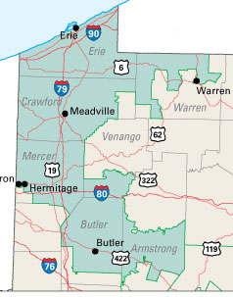

District Office
208 E. Bayfront Parkway Suite 102
Erie, PA 16507
Toll Free: 1-877-KATHY4U (1-877-528-4948)
Local: (814) 456-2038
Fax: (814) 454-0163

Washington D.C. Office
516 Cannon HOB
Washington, D.C. 20515
Phone: (202) 225-5406
Fax: (202) 225-3103

Satellite Offices
Dahlkemper’s updated satellite office locations/hours are as follows:
Armstrong
Armstrong County Commissioner’s Office
450 E Market St
Kittanning, PA 16201
Days of Use: 1st Friday of every month
Constituent Office Hours: 1-4:30 pm
Butler
Butler Township Municipal Building
290 South Duffy Road
Butler, PA 16001
Constituent Office Hours: Tuesdays, Thursdays: 1-4:30 pm/ Wednesdays: 8:30 am-12 pm
Phone: (724) 285 - 3595
Crawford
Meadville City Building
984 Water St
Meadville, PA 16335
Days of Use: 2nd & 4th Thursday of every month beginning March 12th
(Friday, Feb. 27 office hours will be held 1-4 p.m.)
Constituent Office Hours: 9 a.m.-1 p.m.
Mercer
Hermitage Municipal Building
800 N. Hermitage Road, Suite 417
Hermitage, PA16148
Phone: (724) 342-2685
Venango
Emlenton Borough Municipal Building
511 Hill St
Emlenton, PA 16373
Days of Use: 3rd Friday of every month
Constituent Office Hours: 9 a.m.-12:30 p.m.
Warren
Warren County Senior Center
800 Pennsylvania Avenue
Warren, PA 16365
Days of Use: 1st Wednesday of every month beginning March 4.
(Friday, Feb. 27 office hours will be held 1-4:30 p.m.)
Constituent Office Hours: 9 a.m.-1 p.m.

Holden, Tim (PA-17)
http://holden.house.gov
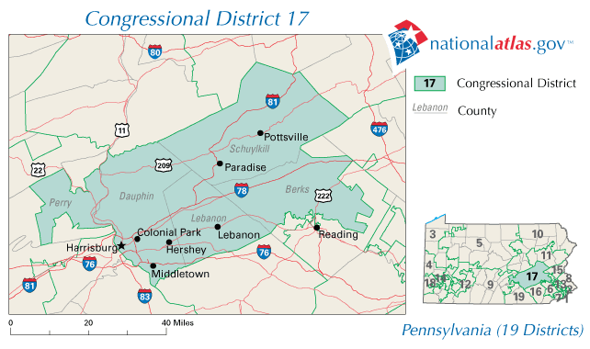

Write to Representative Tim Holden
I am very interested in hearing your views on issues of importance to you. Due to the large volume of US Mail, email and faxes I receive, I am only able to accept messages from residents of the 17th Congressional District of Pennsylvania. Congressional courtesy dictates that Representatives be given the opportunity to assist their own constituents. If you are a resident of another district, I encourage you to contact your Representative in Congress by clicking the following link to the Write Your Representative Service.

Write or Call My Offices Below
Washington Office
2417 Rayburn HOB |
Washington, D.C. 20515
Phone: (202) 225-5546 |
FAX: (202) 226-0996

Berks County Office
4918 Kutztown Road | Temple, PA 19560
Phone: (610) 921-3502 | FAX: (610) 921-3504
Dauphin/Perry County Office
1721 North Front Street | Harrisburg, PA 17102
Phone: (717) 234-5904 | FAX: (717) 234-5918
Lebanon County Office
758 Cumberland Street | Lebanon, PA 17042
Phone: (717) 270-1395 | FAX: (717) 270-1095

Schuylkill County Office
101 North Centre Street | Pottsville, PA 17901
Phone: (570) 622-4212 | FAX: (570) 628-2561

Murphy, Patrick (PA-08)
http://www.patrickmurphy.house.gov

The 8th Congressional District of Pennsylvania includes all of Bucks County, a tiny finger of Montgomery County around Willow Grove and parts of two wards in Northeast Philadelphia

Map not reproducible. See website for map.

Bristol Office
414 Mill Street
Bristol, PA 19007
(215) 826-1963
Fax: (215) 826-1997

Washington Office
1609 Longworth HOB
Washington, DC 20515
(202) 225-4276
Fax: (202) 225-9511

Doylestown Office
72 North Main Street
Doylestown, PA 18901
(215) 348-1194
Fax: (215) 348-1449

For time sensitive problems with federal agencies requiring immediate assistance please call 215-826-1963 for the fastest response.

PENNSYLVANIA BLUE DOG DEMOCRATS
Contact information only

Jason Altmire, (PA-04)
http://www.altmire.house.gov
Main Offices
Please direct all written correspondence to the Aliquippa District Office.

Aliquippa Office
2110 McLean Street
Aliquippa, PA 15001
724-378-0928
724-378-6171 (fax)
Natrona Heights Office
2124 Freeport Road
Natrona Heights, PA 15065
724-226-1304
724-226-1308 (fax)
Washington, D.C. Office
332 Cannon House Office Building
Washington, DC 20515
202-225-2565
202-226-2274(fax)

Satellite Offices
Cranberry Township Office
Cranberry Township Municipal Building
2525 Rochester Road
Cranberry Township, PA 16066-6499
1:30 pm to 5:00 pm - First and Third Thursdays of every month
NOTE: This office will be closed on Thursday, July 3.

Ellwood City Office
Ellwood City Municipal Building
Lawrence Avenue
Ellwood City, PA 16117
2:00 pm to 6:00pm - 2nd and 4th Tuesday of every month

Farrell Office
Farrell City Building
500 Roemer Blvd
Farrell, PA 16121
9 am to 1:00 pm - 2nd and 4th Tuesday of every month

Murrysville Office
Murrysville Municipal Building
4100 Sardis Road
Murrysville, PA 15668
2 pm to 4 pm - Second Tuesday of every month
4 pm to 7 pm - Fourth Tuesday of every month

New Castle Office
Lawrence County Government Center
430 Court Street
1st Floor Caucus Room
New Castle, PA 16101
8:00 am to 4:00 pm - Every Wednesday and Friday

Ross Township Office
Ross Township Municipal Building
Recreation Center
1000 Ross Municipal Drive
Pittsburgh,PA 15237
9:00 am to 12:00 pm - First and Third Thursdays of every month
NOTE: This office will be closed on Thursday, July 3.

Please direct all written correspondence to the Aliquippa District Office.

Carney, Christopher (PA-10)
http://carney.house.gov
Office Information
Washington D.C. Office  416 Cannon House Office Building  Washington, DC 20515  Phone: (202) 225-3731  Fax: (202) 225 9594  Congress in Session:  Office Hours: Monday - Friday, 9:00 - 6:00  Congress in Recess:  Office Hours: Monday - Friday, 9:00 - 5:00 | Shamokin District Office  521 Franklin Street  Shamokin, PA 17872  Phone: (570) 644-1682  Fax: (570) 644-1684  Office Hours: Tuesday - Thursday, 8:00 - 4:30
Clarks Summit District Office  233 Northern Boulevard Suite 4  Clarks Summit, PA 18411  Phone: (570) 585-9988  Toll free: (866) 846-8124  Fax: (570) 585-9977 | Williamsport District Office  175 Pine St. Suite 103  Williamsport, PA 17701  Phone: (570) 327-1902  Fax: (570) 327-1904  Office Hours: Monday - Friday, 8:30 - 5:00

Dahlkemper, Kathy (PA-03)
http://dahlkemper.house.gov

District Office
208 E. Bayfront Parkway Suite 102
Erie, PA 16507
Toll Free: 1-877-KATHY4U (1-877-528-4948)
Local: (814) 456-2038
Fax: (814) 454-0163

Washington D.C. Office
516 Cannon HOB
Washington, D.C. 20515
Phone: (202) 225-5406
Fax: (202) 225-3103

Satellite Offices
Dahlkemper’s updated satellite office locations/hours are as follows:
Armstrong
Armstrong County Commissioner’s Office
450 E Market St
Kittanning, PA 16201
Days of Use: 1st Friday of every month
Constituent Office Hours: 1-4:30 pm
Butler
Butler Township Municipal Building
290 South Duffy Road
Butler, PA 16001
Constituent Office Hours: Tuesdays, Thursdays: 1-4:30 pm/ Wednesdays: 8:30 am-12 pm
Phone: (724) 285 - 3595
Crawford
Meadville City Building
984 Water St
Meadville, PA 16335
Days of Use: 2nd & 4th Thursday of every month beginning March 12th
(Friday, Feb. 27 office hours will be held 1-4 p.m.)
Constituent Office Hours: 9 a.m.-1 p.m.
Mercer
Hermitage Municipal Building
800 N. Hermitage Road, Suite 417
Hermitage, PA16148
Phone: (724) 342-2685
Venango
Emlenton Borough Municipal Building
511 Hill St
Emlenton, PA 16373
Days of Use: 3rd Friday of every month
Constituent Office Hours: 9 a.m.-12:30 p.m.
Warren
Warren County Senior Center
800 Pennsylvania Avenue
Warren, PA 16365
Days of Use: 1st Wednesday of every month beginning March 4.
(Friday, Feb. 27 office hours will be held 1-4:30 p.m.)
Constituent Office Hours: 9 a.m.-1 p.m.

Holden, Tim (PA-17)
http://holden.house.gov
Washington Office
2417 Rayburn HOB |
Washington, D.C. 20515
Phone: (202) 225-5546 |
FAX: (202) 226-0996

Berks County Office
4918 Kutztown Road | Temple, PA 19560
Phone: (610) 921-3502 | FAX: (610) 921-3504
Dauphin/Perry County Office
1721 North Front Street | Harrisburg, PA 17102
Phone: (717) 234-5904 | FAX: (717) 234-5918
Lebanon County Office
758 Cumberland Street | Lebanon, PA 17042
Phone: (717) 270-1395 | FAX: (717) 270-1095

Schuylkill County Office
101 North Centre Street | Pottsville, PA 17901
Phone: (570) 622-4212 | FAX: (570) 628-2561

Murphy, Patrick (PA-08)
http://www.patrickmurphy.house.gov

Bristol Office
414 Mill Street
Bristol, PA 19007
(215) 826-1963
Fax: (215) 826-1997

Washington Office
1609 Longworth HOB
Washington, DC 20515
(202) 225-4276
Fax: (202) 225-9511

Doylestown Office
72 North Main Street
Doylestown, PA 18901
(215) 348-1194
Fax: (215) 348-1449

For time sensitive problems with federal agencies requiring immediate assistance please call 215-826-1963 for the fastest response.

